|  |  |  |  |  |  |  |  |  |  |  |
| --- | --- | --- | --- | --- | --- | --- | --- | --- | --- | --- |
| **Leeds University**  **Business School** | |  | | | | | | | | |
| **Assessed Coursework Coversheet** | | | | | | | | | | |
| For use with *individual* assessed work | | | | | | | | | | |
| Student ID Number: | 2 | | 0 | 1 | 5 | 9 | 6 | 9 | 1 | 8 |
| Module Code: | LUBS2610 | | | | | | | | | |
| Module Title: | Intermediate Macroeconomics | | | | | | | | | |
| Module Leader: | Tadeusz Gwiazdowski | | | | | | | | | |
| Declared Word Count: | 1886 | | | | | | | | | |
| Please Note:  Your declared word count must be accurate, and should not mislead. Making a fraudulent statement concerning the work submitted for assessment could be considered academic malpractice and investigated as such.  If the amount of work submitted is higher than that specified by the word limit or that declared on your word count, this may be reflected in the mark awarded and noted through individual feedback given to you.  It is not acceptable to present matters of substance, which should be included in the main body of the text, in the appendices (“appendix abuse”).  It is not acceptable to attempt to hide words in graphs and diagrams; only text which is strictly necessary should be included in graphs and diagrams. | | | | | | | | | | |
| By submitting an assignment you confirm you have read and understood the University of Leeds [**Declaration of Academic Integrity**](http://www.leeds.ac.uk/secretariat/documents/academic_integrity.pdf) ( <http://www.leeds.ac.uk/secretariat/documents/academic_integrity.pdf>). | | | | | | | | | | |

Assume an economy that starts with 𝑌 = 𝑌𝑛. Illustrate graphically, explain, and critically discuss the impact of an expansionary monetary policy shock (e.g., arise in the money supply or a fall in the interest rate) depending on whether we use a Simple Classical Model, the Blanchard IS-LM-PC model with anchored expectations and endogenous money, or the Anti-Blanchard IS-LM-PC model with anchored expectations and endogenous money where firms have the power to adjust the economy after a shock. You can assume that nominal interest rates will not reach the zero lower bound. Considering empirical evidence and the model’s theoretical assumptions, provide a full and broad critical discussion of the strengths and limitations of the Blanchard IS-LM-PC model.

In this essay, I will demonstrate that the Simple Classical Model (SCM) takes the position of monetary neutrality, meaning that it predicts that a monetary shock will have no impact on output in an economy. I will show that both the Blanchard and anti-Blanchard IS-LM-PC models model expansionary monetary shocks as impactful with respect to current levels of output, inflation and wages and profit. Finally, I will consider a broad range of points for and against the Blanchard IS-LM-PC.

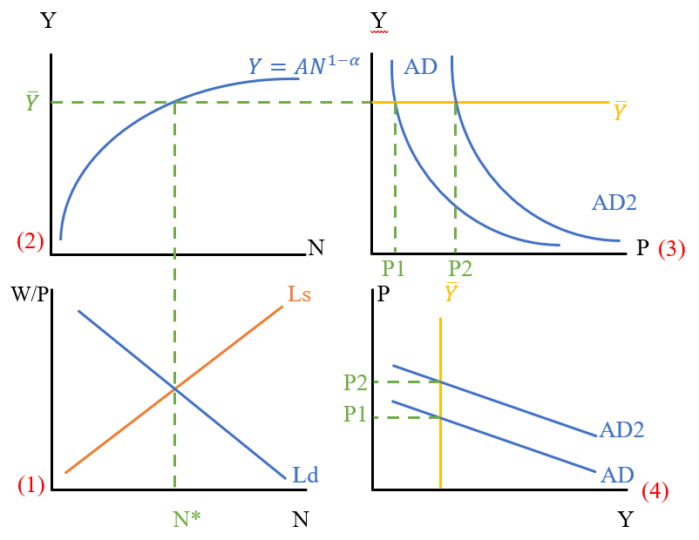

*Figure 1*

In figure 1.1, we find that the equilibrium between labour supply, *Ls*, and labour demand, *Ld,* determines the amount of labour currently being employed, *N\**. In figure 1.2, the equilibrium between N* and our production function determines current output ; this determination is possible because we are assuming that .

Output in the economy isdetermined by labour supply and demand, which, in the SCM, have no relationship with the money supply or the interest rate. Instead, changes in monetary policy only affect aggregate demand, which is defined by the relationship between money supply and the price level, , where we assume . In figure 1.3, AD is defined by the equation , however this relationship is often approximated to the straight line seen in figure 1.4. In the SCM, *Y* is always fixed where , so we substitute . This implies that, to maintain output fixed at , a rise in the money supply requires an equal rise in the price level and vice versa, so P1 shifts to P2. To summarise, the SCM predicts that an economy experiencing an expansionary monetary shock will face an increased price level, while their level of output will stay the same.

Blanchard’s IS-LM-PC models expansionary monetary shocks as influential with respect to current levels of output, inflation and wages and profit.

*Figure 2*

In figure 2.1, an expansionary monetary shock is modelled as the central bank decreasing the interest rate from to . In endogenous money theory, the LM curve is perfectly elastic at the real interest rate, so the LM curve also shifts downwards. The IS-LM relationship, previously determining output at Yn, now determines output at level Y. When , the Phillips curve relationship models an inflationary period in the economy, exemplified in figure 2.4. In figure 2.5, we model the impacts of inflationary interest rates on workers and firms in the economy. Before the monetary shock, the total product in the economy is represented by the blue and yellow areas. The yellow portion is given to workers in the form of wages, and the blue portion earned by firms in the form of profit. After output increases, the total product of the economy is represented by blue, green, yellow, and orange areas, with workers and firms gaining the orange and green areas, respectively. The distribution of the total product of the economy, then, is dependent on the price setting curve, as this curve delineates the workers’ section from the firms’ section. To summarise, Blanchard’s IS-LM-PC model posits that an expansionary monetary shock will lead to inflation and an increase in the total output of the economy. The benefits of this extra output will be distributed to workers and firms depending on the price-setting relation, and thus the mark-up.

The anti-Blanchard IS-LM-PC agrees with the Blanchard model, insofar as it concerns the process I have already explained. However, the anti-Blanchard model argues that following this process, the potential output Yn in figure 2.5 will adjust to the output Y, because of a desire among workers and firms to lower inflation. This adjustment can happen in two different ways, and will be determined by whether firms or workers have the most power in a given economy.

*Figure 3*

In figure 3, we see what happens when firms dominate the economy. Rather than reduce mark-up, firms force workers to accept lower wages, which is modelled as a fall in their bargaining power. This shifts WS to WS2, causing Yn(t-1) to shift to Yn and PC to shift to PC2, ending the inflationary period as seen in figure 3.4.

In general, Blanchard’s IS-LM-PC has a few key strengths over other models, when realistically modelling economies and making predictions. First, considering assumptions, both IS-LM-PC models share a strength over the SCM, since the formers’ implicit time dynamics and assumption of imperfectly competitive markets are more realistic than the latter’s complete stasis and assumption of perfect competition. Second, considering empirical data, the consensus on monetary neutrality seems to be that it is false, i.e., contrary to what the SCM predicts, monetary shocks do affect output. This is supported by Romer and Romer (1989), Christiano et al. (1999, 2005) and Coibon (2012).

The Blanchard IS-LM-PC model also has some weaknesses. First, Blanchard’s IS-LM-PC differs from the simple IS-LM-PC model in an important way, that it includes the theory of hysteresis, pioneered by Blanchard. Essentially, the theory suggests that a shock in the economy may continue to have an effect, even after the shock has been dealt with, e.g., unemployment may bounce back *lower* after a full recovery from a recession. However, this theory lacks strong evidential support: Liew et al. (2009) found that an analysis of 14 different OECD countries rejects the hysteresis hypothesis. Another weakness exists in the fact that changes in wages in the labour market in figure 3.5 don’t lead to a change in consumption in the economy, which would shift the IS curve, making the model less realistic.

Use the three-panel internal economies of scale diagram to show the overall impact of trade integration between two identical economies. Now, assume the UK was at 𝑌 = 𝑌𝑛 when the UK left the European Union. Given the change in the average mark-up in the UK due to Brexit implied by your analysis in the first part of your answer, use the Blanchard IS-LM-PC model alongside a graph of inflation over time to explain the impact of this change in the mark-upon the UK economy under two scenarios: i) if the central bank responds by raising interest rates versus ii) if there is higher immigration to the UK. Discuss the overall macroeconomic impact of Brexit on the UK economy between 2016 and 2022.

In this essay, I will demonstrate that the overall impact of trade integration in two identical economies is a decrease in mark-up and an increase in the number of companies. Next, I will extend my analysis to trade *disintegration* between the UK and the EU during Brexit, that being that mark-up is increased and the number of firms decreases, although not to pre-EU levels. As a result of this increased mark-up, the UK economy could respond in one of two ways. First, I will show the effects of the central bank responding by changing interest rates, and second, I will show the alternative effect of increase immigration. Finally, I will demonstrate that the overall macroeconomic impact of Brexit on the UK economy has been negative.

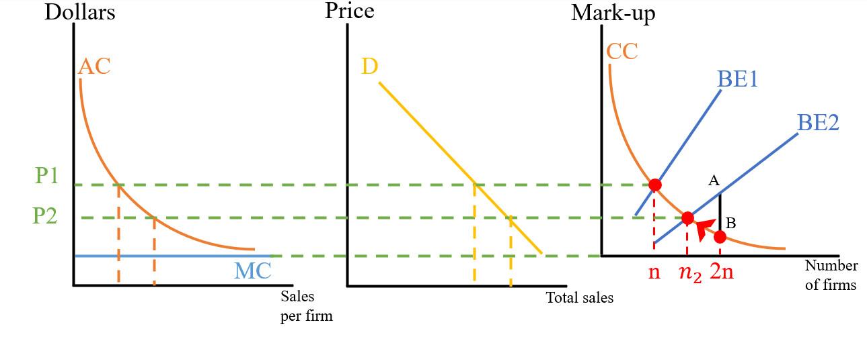

*Figure 1*

In figure 1, the effect of integrating two identical economies is expressed by internally analysing the number and size of firms, and mark-up. There are two important effects when it comes to integration: first, the customer base which firms sell to doubles in size, meaning it is easier for firms to break-even as they sell more products and can retain the same level of revenue even while lowering mark-up. This has the effect of shifting the break-even curve from BE1 to BE2. Second, the total number of firms doubles from n to 2n. At this number of firms, the competition curve CC determines that they must sell at price B, but they require price A to break even. So, firms either leave the market completely, are acquired, or merge with others until the number of firms decreases and the equilibrium between CC and BE2 is reached – at this point, the price given by competition is enough to break even and we reach a steady state. To summarise, integration of two identical economies will lower prices and increase the number of firms, however this number will not be double the original number.

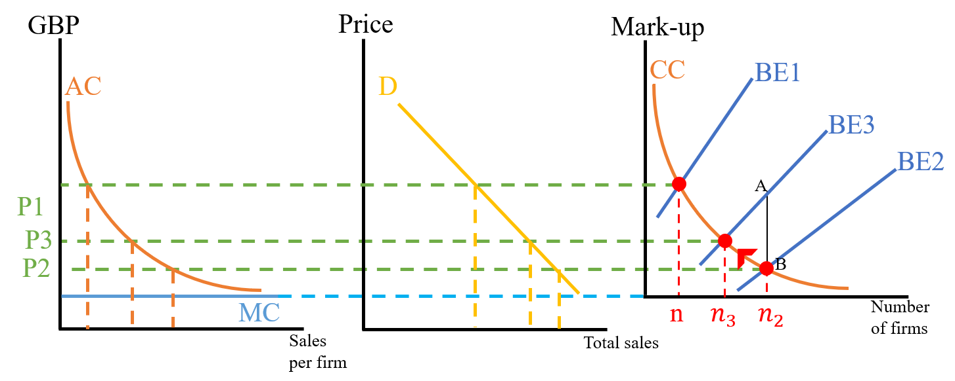

*Figure 2*

In figure 2, we see the effects of the UK disintegrating from the EU. BE1 represents the break-even curve *before* the UK joined the EU, BE2 represents the break-even curve during EU membership, and BE3 represents the break-even curve *after* Brexit. BE3 lies between BE1 and BE2 because, post-Brexit, the customer base for firms is still greater than the customer base pre-integration due to the post-Brexit free trade agreement with the EU. Following disintegration, the number of firms is unstable at because firms require price A for their goods but can only set price B because of competition. Like before, firms leave and are acquired until a new equilibrium is reached at . Thus, Brexit results in a higher mark-up, fewer firms and possibly larger firms, and less total sales in the British economy.

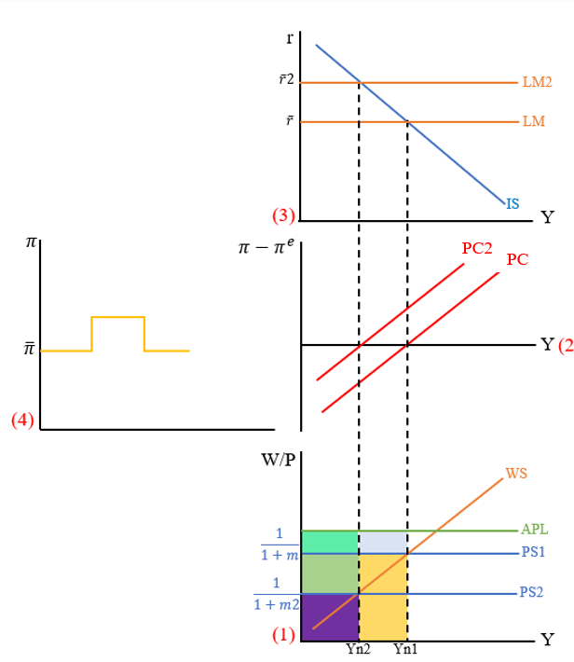

*Figure 3*

Figure 3 shows the effects of a greater mark-up in the British economy and a subsequent response by the central bank. Mark-up increases from m to m2, shifting PS1 down to PS2. This changes the natural rate of output Yn1 to Yn2, shifting the Phillips curve PC to PC2. Because our level of actual output is determined by the IS-LM relation, Y remains the same and consequently , meaning we are in an inflationary period. Inflation jumps up to a new level, shown in figure 3.4. As a response to inflation, the central bank increases the interest rate from . We assume an endogenous theory of money, meaning that the LM curve will always be perfectly elastic at the interest rate set by the central bank, and thus LM shifts up to LM2. This lowers the current level of output from the previous natural rate Yn1 to the new natural rate Yn2; this lowers inflation down to its previous level. Before the change in mark-up, the workers’ share of the total economic product was the purple, green and orange areas; the firms’ share was the turquoise and light blue areas. After the central bank response, the total product has shrunk and mark-up has increased so the workers’ share has unambiguously fallen to the purple area. Meanwhile, firms have lost the light blue area but gained the purple area. To summarise, a central bank response to an increase in mark-up curbs inflationary effects but unambiguously cuts worker compensation. The change to firm profits is less clear: it could be the case that the new area gained is smaller than the area lost, or vice versa.

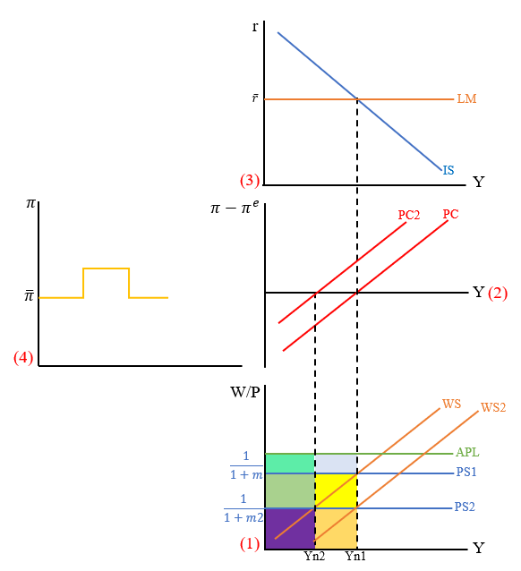

*Figure 4*

Figure 4 shows the impact of immigration on the British economy following a rise in mark-up. The process is the same as I described earlier, however, rather than the central bank intervening, a rise in immigration happens instead. This rise in immigration weakens worker bargaining power by increasing competition amongst workers, causing WS to shift downwards to WS2. This causes Yn2 to return to Yn1, shifting PC2 back to PC and ending the inflationary period. In total, the workers lose the green and yellow areas to firms: there has been an unambiguous fall and gain in workers’ and firms’ shares, respectively.

Because of the numerous shocks that the UK has experienced following the decision to leave the EU in 2016, data surrounding Brexit is hard to quantify. However, we can synthesise key criticisms from the theory and data. First, while net migration in the UK has increased in recent years, this is very unlikely to sufficiently shift the natural rate of output back to its pre-Brexit levels, as seen in figure 4. Second, the EU-UK Trade and Cooperation Agreement distances our trade relationship with the EU, strengthening the conclusions reached from figure 2. Technical barriers to trade are the key problem – for example, the trade between the EU and UK must pay VAT on import rather than at the point of service. These technical barriers strengthen the conclusion that UK firms’ customer base has shrunk, leading to an increased mark-up and smaller economy.